

***NAME: SARWAT AIJAZ***

***ROLL #: 22SW024***

***SECTION: 3***

***TYPING TUTOR DOCUMENTATION***

***ABOUT:***

This simple typing tutor program written in C++ by using OOP concepts is designed for complete beginners to help them with basic typing practice.

***CODE EXPLANATION:***

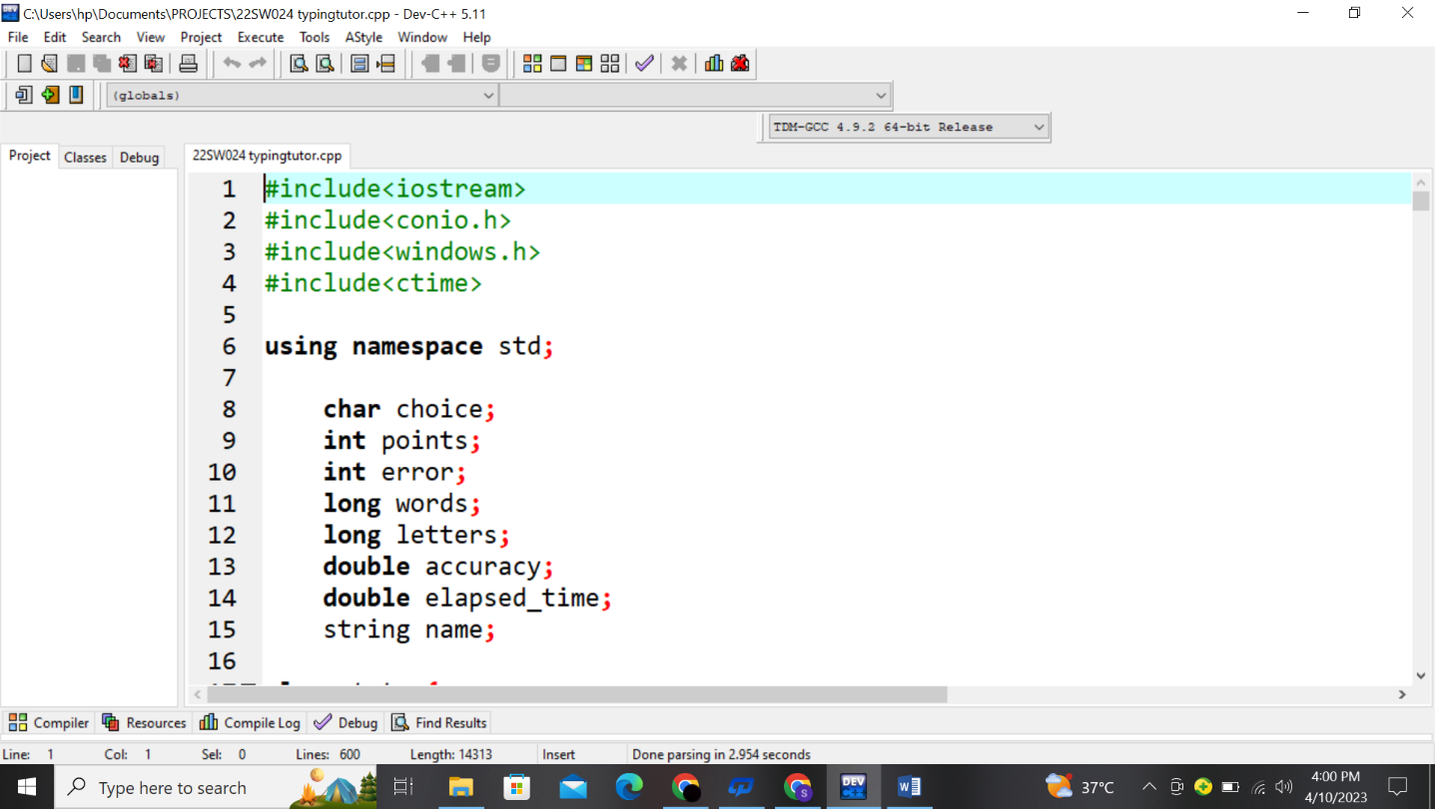

Here, Header files like conio.h for getch() function, windows.h for changing the font colors and ctime for calculating the total time taken are used respectively. Some common needed variables like calculating how much correct words the user typed counting them in points likewise how many wrong characters were typed by the user and counting those in error are used and hence calculating accuracy with the help of points and errors. Here **words** and **letters** are used separately as words is used for counting the number of words (consisting of various letters) are typed and letters itself is used for counting how many letters are included in each word.

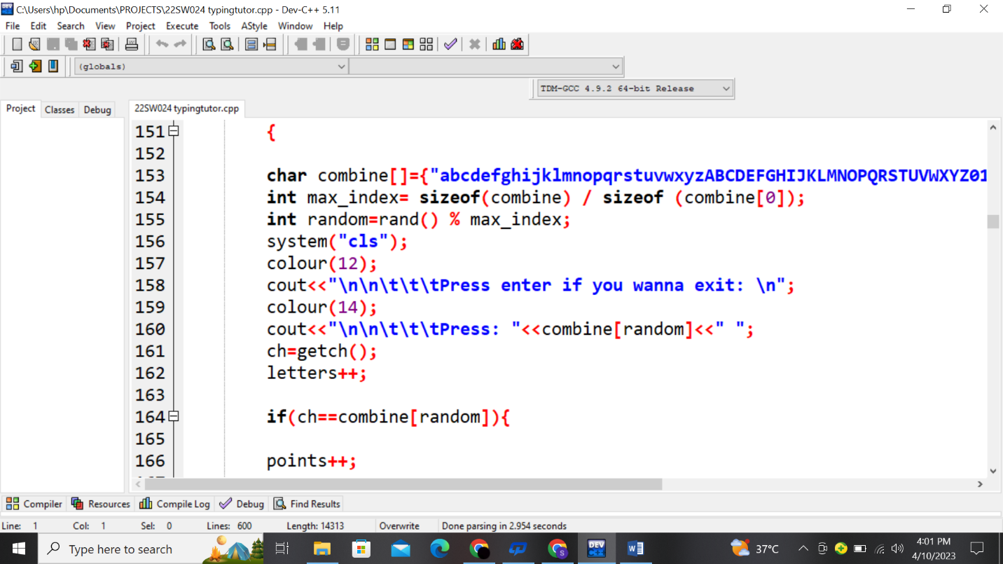

Starting with a basic part of the program, in which alphabets (both uppercase and lowercase) and numbers from 0 to 9 are stored in a character array. Then rand() function is used for generating random characters from the array so the user can type a random character that is being displayed at the console. This whole process of typing random characters is followed by **do-while loop** in which the loop will keep asking the user to type until the user presses enter.

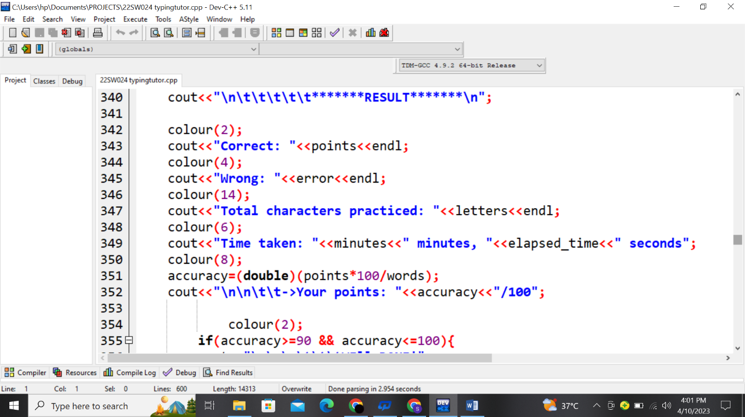

After finishing of typing the words or characters, if user presses certain keys like pressing enter or typing ‘quit’ depending on which part of the typing tutor they are, result is ultimately calculated with the help of errors and points made by the user.

***OUTPUT:***

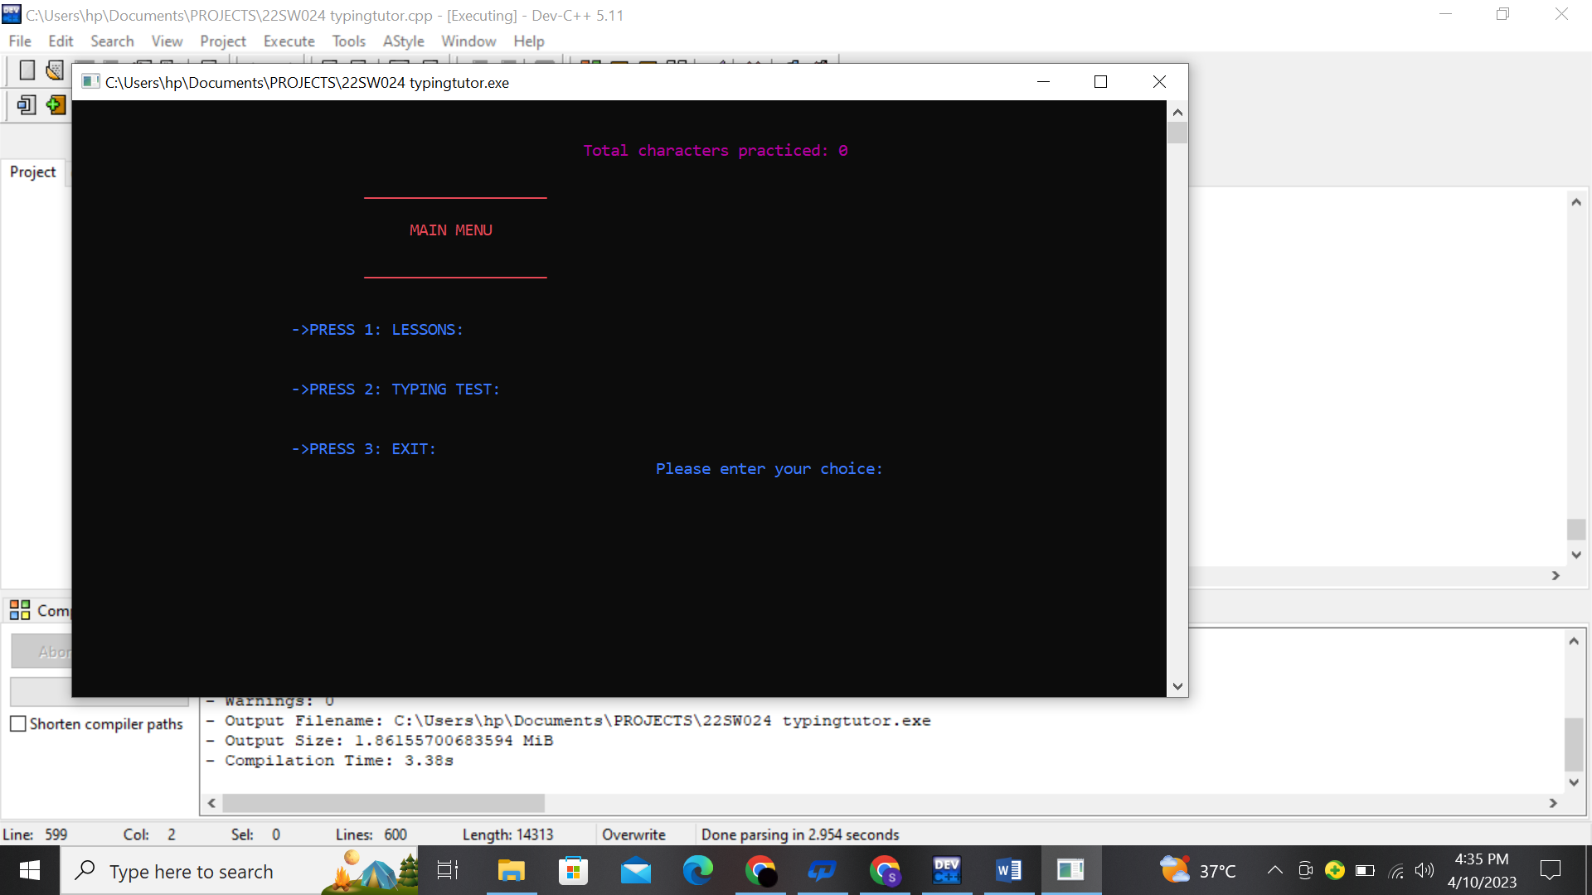

Main menu consists of various options allowing the user to select a particular choice. On the top, total characters that will be typed by the user before exiting will be displayed.

If the user tends to go for typing lessons, two options will be displayed and the characters shown in these options will be displayed randomly. In case typed wrongly, a beep sound would be generated using escape sequence ‘\a’.

If the user goes to typing lessons, he/she has two choose between countries and animals for the test. Instructions are also generated whenever user wants to go to any option.

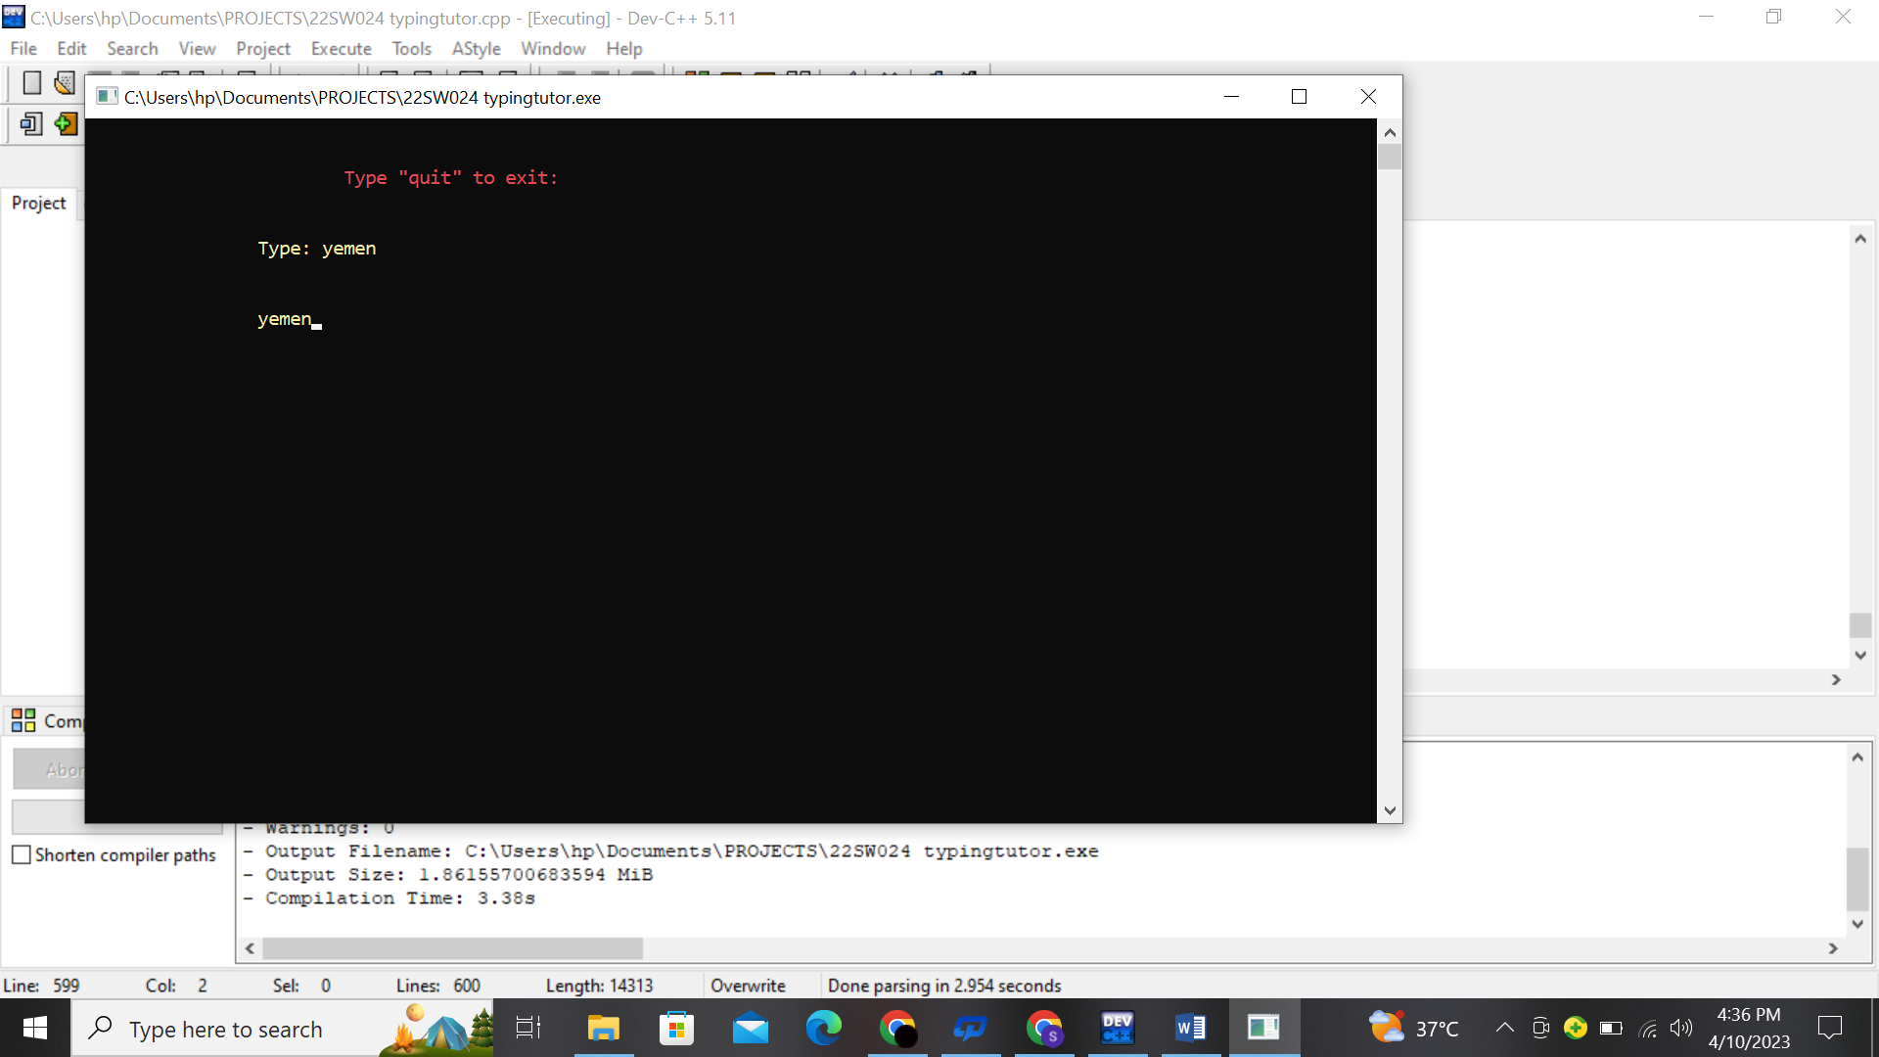

A visual representation of how user can interact with this program. Note that in typing test, time will also be calculated along with the number of words that are being typed, this will show how fast user’s typing skills are.

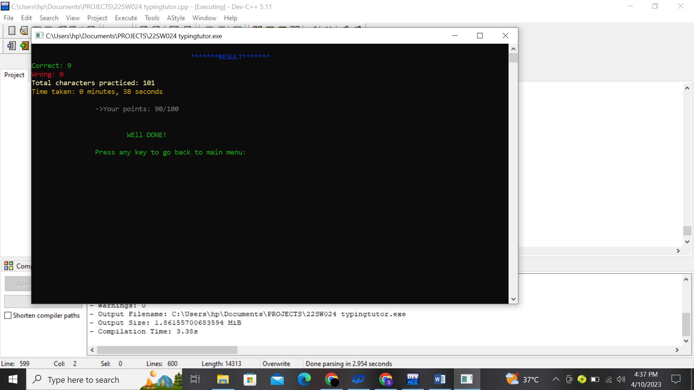

Lastly, after exiting the typing test, user’s result of typing correct/ wrong words along with the total characters that user typed with each word (passing this as an argument to the function consisting main menu) is displayed with the total time taken and some constructive comments.